**Stock Exchange Website Testing Description**

**Apache jmeter Software:**

**JMeter is** an open source desktop Java application that **is** designed to load test and measure performance. It **can** be **used** to simulate loads of various scenarios and output performance data in several ways, including CSV and XML files, and graphs.

**Tools:**

Following tools that helps the jmeter to test the website testing

1. BlazeMeter Software
2. BadBoy Software
3. **BlazeMeter Software:**

BlazeMeter is a next-generation SaaS, Cloud and on-premise continuous testing solution designed to help DevOps and Agile teams shift left their testing by running web, mobile, microservices and API testing early in the application development stage. By running functional, API or massively scalable load tests at any time and from anywhere, developers can validate performance and functionality at every software delivery stage.

Founded in 2011 by Alon Girmonsky, BlazeMeter started out as a load and performance testing solution, enhancing the capabilities of the leading open source tool JMeter. Since this date, BlazeMeter has significantly expanded its testing suite and enriched its support of open source tools, such as Locust, Gatling, Selenium, Jenkins, and more.

1. **BadBoy Software:**

Badboy is a powerful tool designed to aid in testing and development of complex dynamic applications. Badboy makes web testing and development easier with dozens of features including a simple yet comprehensive capture/replay interface, powerful load testing support, detailed reports, graphs and much more!

**Browser Use:**

* Brave Browser
* FireFox Browser
* Microsoft Edge

**Sign Up Testing Files:**

File Use in Testing:

* stockweb_signup_testing_jmeter.jmx
* stockweb_signup_testing-Combined-JMeter-and-Selenium.yaml
* stockweb_signup_testing-Selenium.yaml

**Jmeter Testing:**

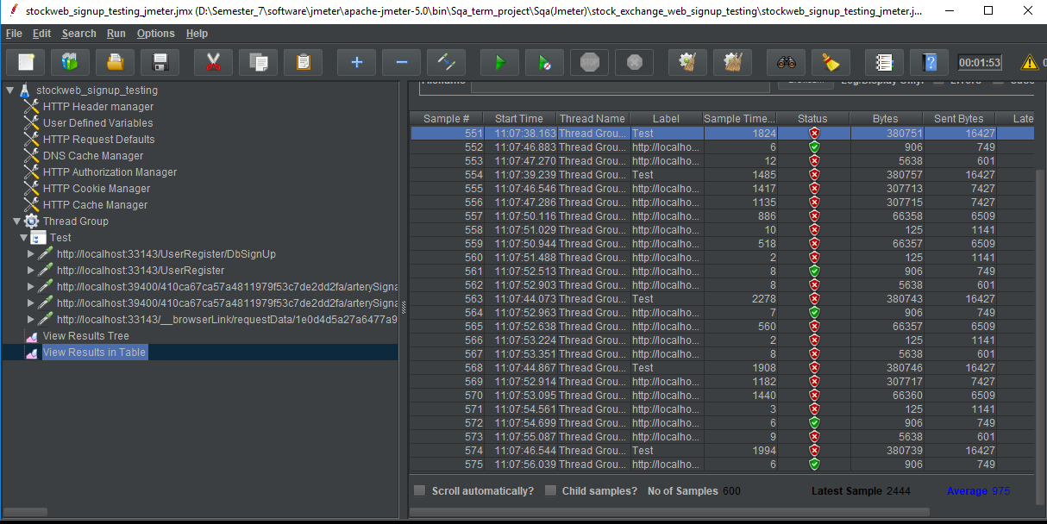

**Signup in cmd Prompt:**

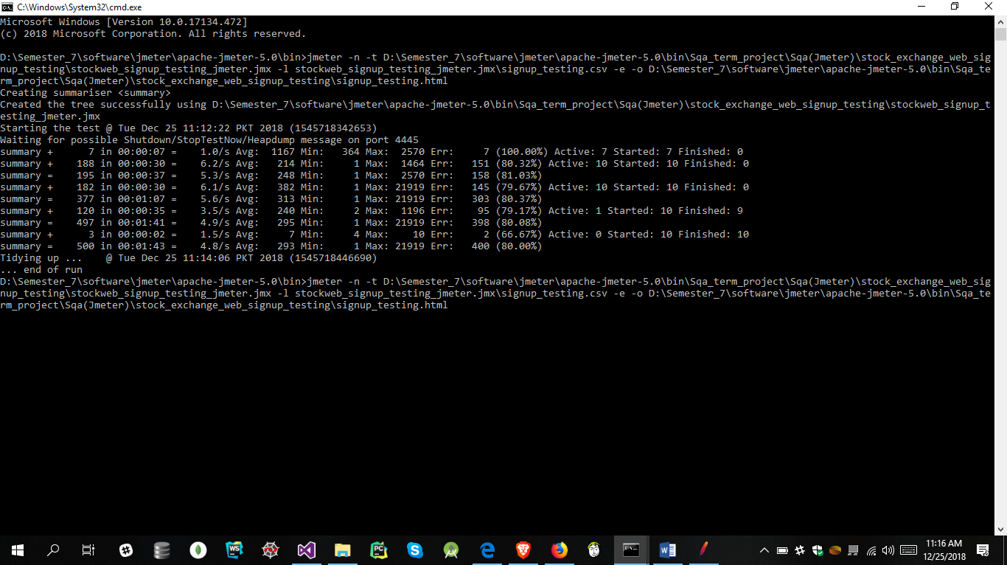

**Badboy Software Testing:**

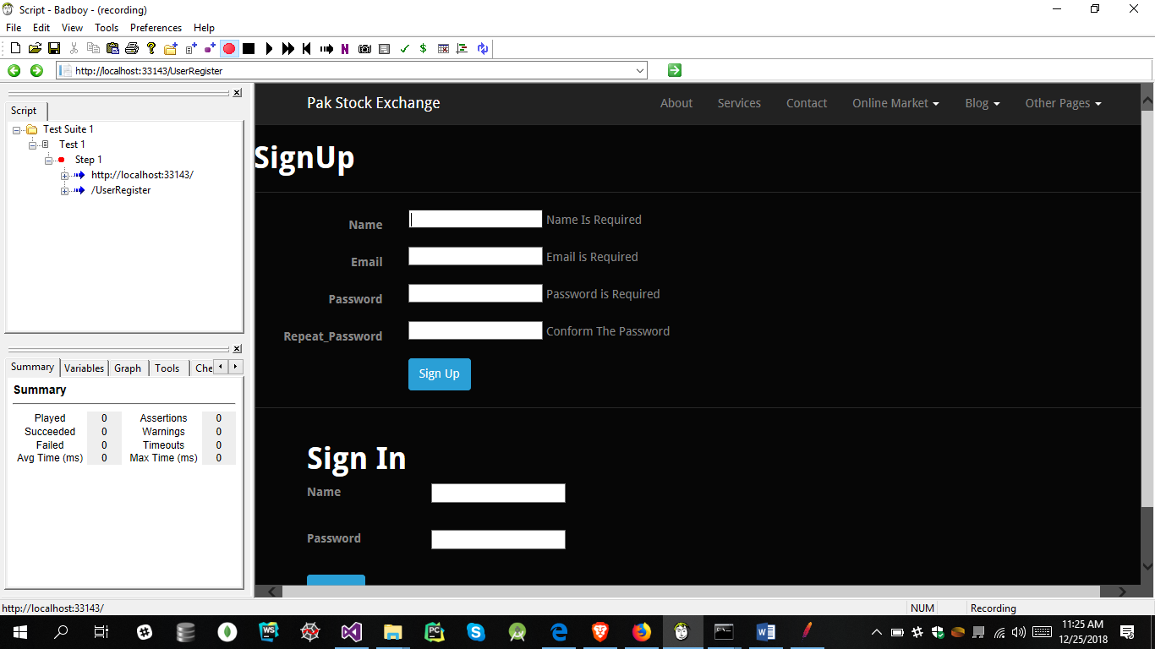

**BlazeMeter Testing:**

